**DEVELOPING AN APPLICATION FOR BOOKING RESTAURANTS**

**Senior Project Report**

**ABDULAZIZ KHALIL ALWAGDANI**

**ANMAR AYMAN BAJNAID**

**ESSAM SAMI ALGHAMDI**

**INFORMATION TECHNOLOGY DEPARTMENT**

**KING ABDULAZIZ UNIVERSITY**

**SAUDI ARABIA**

**1444-2023**

**DEVELOPING AN APPLICATION FOR BOOKING RESTAURANTS**

**Project Report Submitted in Partial Fulfillment of the Requirements for the Degree of**

**Bachelor of Science**

**in**

**COMPUTER SCIENCE**

**By**

**ABDULAZIZ KHALIL ALWAGDANI (1942491)**

**ANMAR AYMAN BAJNAID (2035770)**

**ESSAM SAMIALGHAMDI (2036013)**



**COMPUTER SCIENCE DEPARTMENT**

**FACULTY OF COMPUTING AND INFORMATION**

**TECHNOLOGY AT RABIGH**

**SAUDI ARABIA**

**2023**

**Computer Science Department**

Faculty of Computing and Information Technology

(KING ABDULAZIZ UNIVERSITY)

RABIGH

2023



# CERTIFICATE

This is to certify that this project report entitled “Booking Restaurants” by Abdulaziz Khalil, Anmar Ayman Bajnaid, and Essam Sami Alghamdi submitted in partial fulfillment of the requirements for the degree of Bachelor of Science in Computer Science (CS) of King Abdulaziz University, Rabigh, during the academic year 2023-2024, is a record of work carried out under our guidance and supervision. The results embodied in this report have not been submitted to any other University or Institution for the award of any degree or diploma.

Supervisor Name Chairperson Name

Dr. Abdulaleem Ali Almazroi Dr. Abdulaleem Ali Almazroi

Signature: Signature:

# DECLARATION

I declare that this “Booking Restaurants” projects the result of my research except as cited in the references. The project has not been accepted for any degree and is not concurrently submitted in the candidature of any other degree.

Signature: ....................................................

Name : Abdulaziz Khalil Alwagdani

Date : 07 JUNE 2022

Signature: ....................................................

Name : Anmar Ayman Bajnaid

Date : 07 JUNE 2022

Signature : ....................................................

Name : Essam Sami Alghamdi

Date : 07 JUNE 2022

# DEDICATION

We dedicate this thesis to our parents and to our teachers who guided and supported us during all these last years and enlightened our life with knowledge and virtue.

# ACKNOWLEDGEMENT

In preparing for this project, we were in contact with many people, researchers, academicians, and practitioners. They have contributed to my understanding and thoughts. In particular, we express our sincere appreciation to our main project supervisor, Dr. Abdulaleem Ali Almazroi, for his encouragement, guidance, criticism, and friendship. our sincere appreciation also extends to all our colleagues and others who have aided us on various occasions. Their views and tips are useful indeed. Unfortunately, it is impossible to list them in this limited space. We are grateful to our family members.

# ABSTRACT

The ulterior motive of this application is to manage everything correlated to managing a restaurant and tables in a restaurant. The regular restaurant service is typically laid back: Waiters should associate with customers straightly before dealing with their requests. Nonetheless, a great system should always be focused on customers which should expeditiously perceive consumer charisma, front- runner cuisines. This application gives users the advantages of active ordering as well as hold their accessible table. This system is involved in the use of three applications combine with each other, and involved the use of five modules that are table reservation with food ordering at the same time and get in touch with us. This application also holds the data for the admin (manager of particular restaurant) which includes payments, number of orders and also the admin can dynamically change the menu accordingly with prices with blocking the table booking option for the users subjected to the availability of table. Customers and management can have the data using analytics. This application is capable of multiplying the reputation of the restaurant as well as the customers with accelerated services.

Keywords: booking table, table reservation, restaurant

# Table of contents

TITLE

CERTIFICATE 3

DECLARATION 4

DEDICATION 5

ACKNOWLEDGEMENT 6

ABSTRACT 7

Table of contents 8

List of Figures 10

Chapter 1 INTRODUCTION 11

1.1 Introduction 11

1.2 Problem Background 11

1.3 Project Questions 12

1.4 Project Objectives 12

1.5 Project scope 12

1.6 Importance of Study 12

1.7 Project Schedule 13

Chapter 2 LITERATURE REVIEW 14

2.1 Introduction 14

2.2 Describe our project 14

2.3 Restaurant Reservations in general 15

2.4 The Impact of Technology Use on Value 16

2.5 Programming in general 18

• Programming Languages Type 18

❖ Flutter 19

❖ DART 20

2.6 MySQL 21

2.7 Related Studies 22

• My Table 22

• Requeue 22

2.8 Comparing with existing systems 23

2.9 System Benefits 23

Chapter 3 RESEARCH METHODOLOGY 25

3.1 Introduction 25

3.2 Methodology 25

3.3 Justification of the methodology 25

3.3.1 UML Method 25

3.3.2 System Development Life Cycle (SDLC) 26

3.3.2.1 Methodology Prototype 26

3.3.2.2 Project Planning Phase 27

3.3.2.3 Analysis of Project Requirement Phase 27

3.3.2.4 Prototype Design Phase 27

3.3.2.5 Coding and Prototype Development Phase 28

3.3.2.6 Testing Phase 28

3.3.2.7 Updating and Maintenance Phase 28

3.4 Justification of Choosing Evolutionary Prototype 28

3.5 Analyze system requirements 29

3.6 Summary 29

Chapter 4 SYSTEM ANALYSIS AND DESIGN 30

4.1 Introduction 30

4.2 Result for Software Requirement 30

4.2.1 Functional Requirement 30

4.2.2 Non-functional 30

4.3 Use Case Diagram 31

4.4 Activity diagram 32

4.5 Sequence diagram 33

4.6 Database Design 35

4.7 Conclusion 35

References 36

# List of Figures

Figure 1 PROJECT SCHEDULE 13

Figure 2 Flutter Badge [5] 20

Figure 3 Dart Badge [8] 21

Figure 4 Protoype Model 26

Figure 5 Use Case Diagram 31

Figure 6 Activity Diagram 32

Figure 7 Sequence Diagram 33

Figure 8 Sequence Diagram 34

Figure 9 Database design (ERD) 35

# Chapter 1

# INTRODUCTION

## 1.1 Introduction

This application project allows users to reserve a table in a specific restaurant with flexibility of date and time, in addition to ordering food directly after reserving the table. Here the time when the person comes and takes the order will be saved and also allowed. The user can request a table reservation, specify the number of people and manage their reservations. It also includes the option of fast food using their mobile phones from anywhere with the help of internet connection.

This application also helps the admin (restaurant manager) to dynamically edit the menu with prices and get an overview of table allotment according to the schedule and sending food to a particular table according to the schedule by table number. It also includes data analytics where the admin has a clear view of the orders and the admin can view his orders from any angle regardless of location.

secondly. The main goal of this project is to give the restaurant management a software that makes it easier to manage customers. This app also helps customers place an advance order from home or workplace to book the table and also provides the option of taking food from the restaurant itself. This application is responsible for maintaining waiters, menu items, pricing, payments, and orders. The ultimate goal is to bring all categories of restaurants into one platform for all small restaurants and fine dining restaurants. This app is useful for last minute planning.

## 1.2 Problem Background

The problem background in the provided text relates to the challenges faced by traditional restaurants in managing their operations efficiently. Here are the key issues mentioned:

Lack of Efficient Management: Traditional restaurants often rely on manual, pen-and-paper systems for managing reservations and orders. This can be time-consuming and prone to errors, leading to inefficiencies in restaurant operations.

Customer Service: The text mentions that regular restaurant service is typically "laid back," suggesting that wait staff may not always be attentive to customer needs or preferences, which can result in a less-than-ideal dining experience.

Table Turnover: Efficiently managing table turnover is essential for maximizing restaurant revenue. Slow service or inefficient table management can lead to longer wait times for customers and fewer tables being served throughout the day.

Menu Management: The text discusses the importance of being able to dynamically change the menu and prices. Traditional printed menus can be inflexible and may not easily accommodate changes in menu items or pricing.

Admin Tasks: The text also mentions administrative tasks, such as tracking payments and the number of orders. These tasks can be time-consuming and may require manual record-keeping, which can be prone to errors.

Enhancing Reputation: Finally, the text suggests that the Android application aims to enhance the restaurant's reputation by offering accelerated services and improved customer experiences.

In summary, the problem background revolves around the need for more efficient and customer-focused management of restaurant operations, including reservations, order management, menu updates, and administrative tasks, with the goal of improving the overall dining experience and restaurant reputation. The proposed Android application aims to address these challenges.

## 1.3 Project Questions

Before we begin our project, we must ask the following questions:

1. Who is the project's target group and who will benefit from the project?

2. Does this project have a long-term impact on the restaurants process?

3. Does this project have the potential to improve the social knowledgement?

## 1.4 Project Objectives

During the development of Saudi tourism and the increased interest in restaurants, we aim to organize activities related to restaurants by organizing reservations and queues to reduce waiting and unwanted crowding.

## 1.5 Project scope

The following are the only assumptions that apply this assignment’s

work:

1. This system provides the possibility to guarantee reservations in the restaurants when conformation is made.
2. This system provides many restaurants in one application.
3. This system only focuses on fine dining restaurants.

## 1.6 Importance of Study

In today’s fast-paced world, where time is a valuable commodity, technology continues to reshape the way we live, work, and dine. One significant transformation in the restaurant industry is the introduction of restaurant booking applications. These digital platforms have revolutionized the way we make reservations, enhancing the dining experience for both customers and restaurant owners alike.

## 1.7 Project Schedule

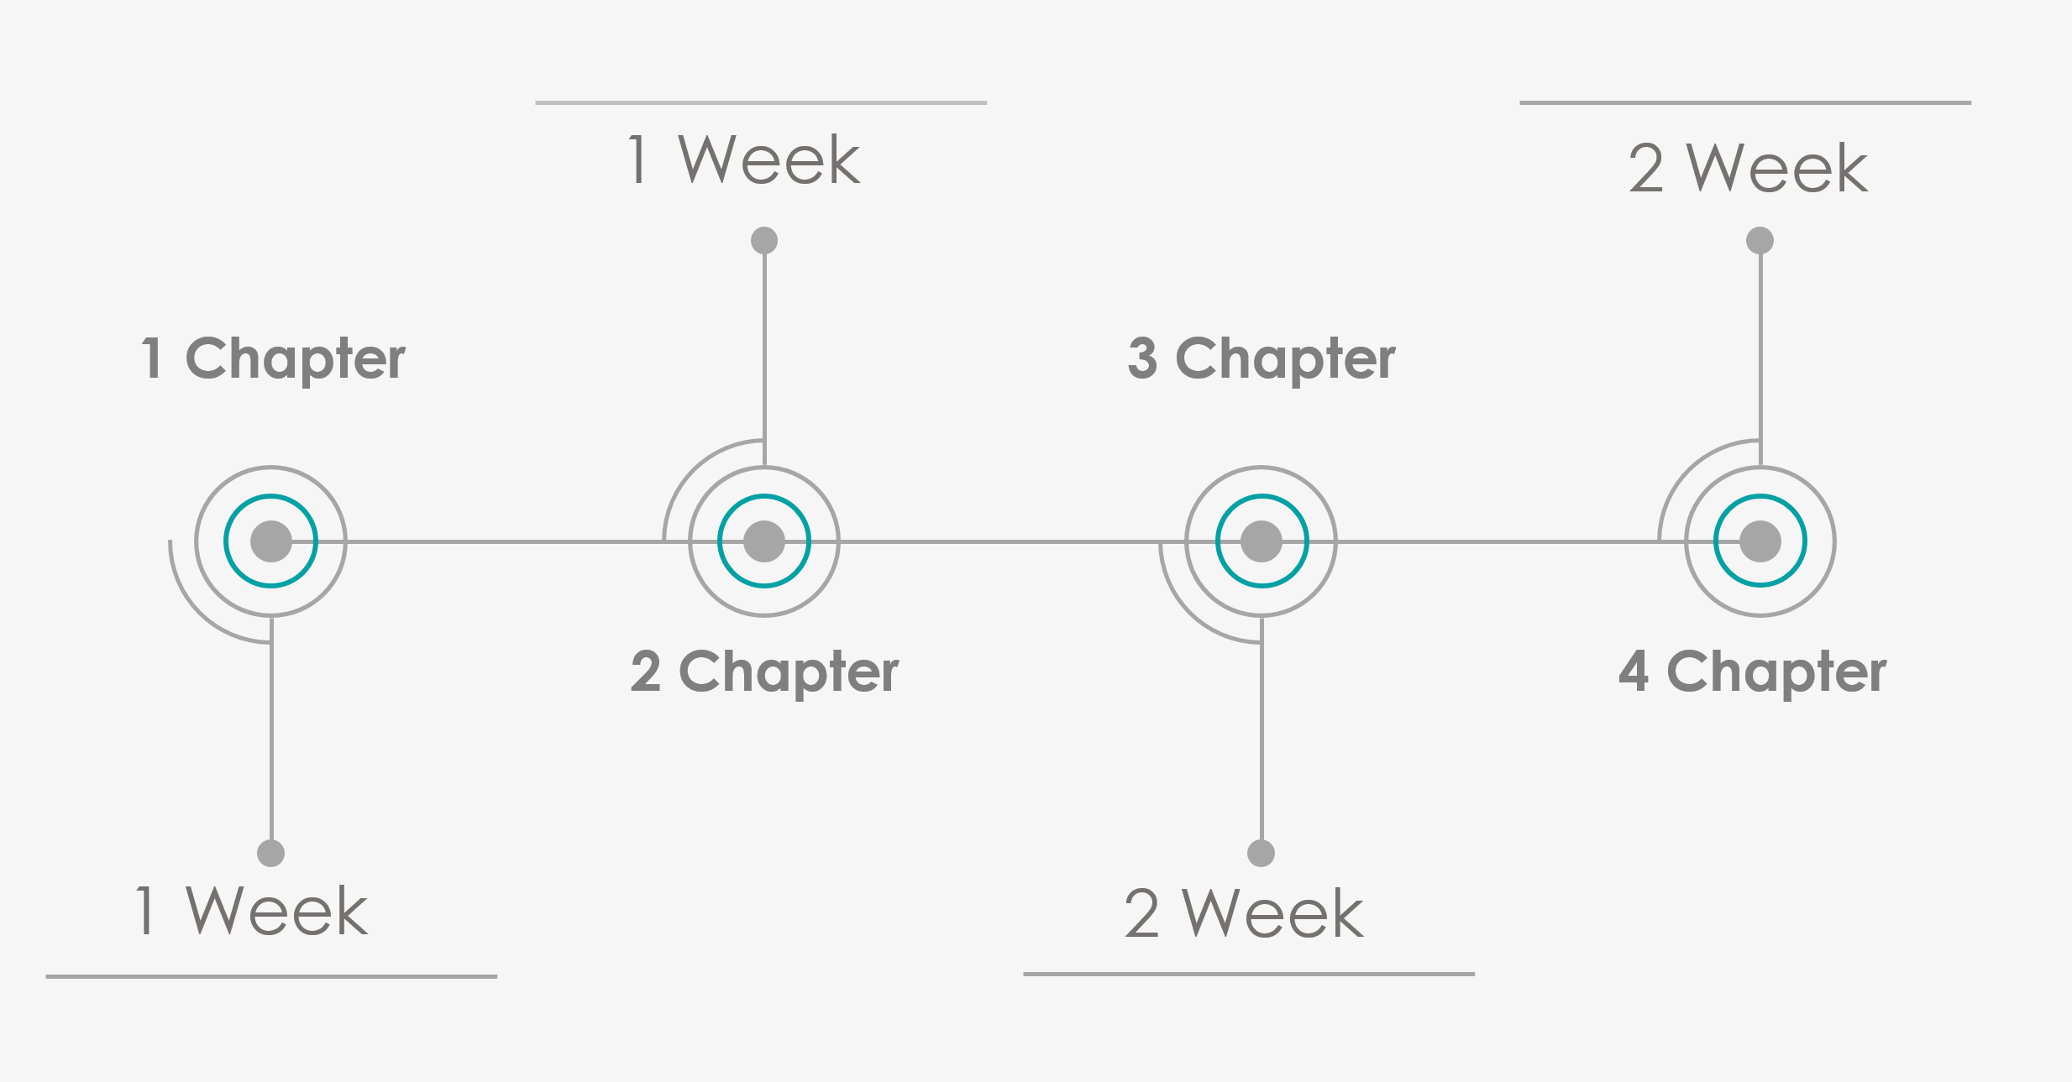

Figure 1 PROJECT SCHEDULE

# Chapter 2

# LITERATURE REVIEW

## 2.1 Introduction

In this chapter, we will present the results of our project for some problems that people constantly face nowadays. We used the internet and some other resources to project for such projects. We found a few ideas that is similar to the project we are doing, but we did not find any platform that has special features like our platform. We will give a brief description of this platform and we will mention its main functionalities in our project.

## 2.2 Describe our project

In our project, we aim to establish a platform that serves Restaurants and clients, we aim to create a platform that provides services to people who need to use reservation service in restaurants. This platform connects people of all genders and ethnicities with different types of restaurants. This platform targets restaurant customers with the aim of facilitating interaction between the target restaurant and the customer. One of the most important goals of the platform is that it saves a lot of time and effort for customers and restaurant employees, so that the person can manage reservations and order details from outside the restaurant through this platform. Secondly, it is a platform that facilitates users to find reservations from various restaurants so that the person can make all the details of reservations, number of seats, payment and more other details through the application. The customer can also specify and reserve the meals he wants to eat upon his arrival time. It will also make it easier for restaurants to provide meals on time and provide the best services based on prior request through the platform. The platform also requires zero experience to deal with it because the application is easy to handle for young or old, novice or expert. The platform also aims to improve the quality of restaurants, increase the number of customers, and raise the level of efficiency between the customer and the restaurant.

## 2.3 Restaurant Reservations in general

Reservations not only give restaurants the opportunity to select the most profitable mix of customers but also help them better schedule their staff and workflow (Fischer, 2005). Reservations give customers an assurance that capacity has been set aside for them and give customers more control over their time (Kimes and Wirtz, 2007). [1]

In an ideal world, customers would show up exactly on time and service times would be completely predictable; unfortunately, not all customers honor their reservations, some show up late or early and service times are not always predictable. These problems have caused many casual restaurants to eschew reservations, but about a third of the largest US casual restaurant chains have take reservations 3 because customers prefer to have them (Kimes and Wirtz, 2007). The question is one of how restaurants can obtain the advantages of reservations while managing the potential problems. [1]

Benefits of Restaurant Reservations:

Here are a few benefits of Restaurant Reservations for customers:

1. Improved convenience

Service convenience is related to customers’ desire to conserve their time and effort. An increase in convenience is associated with an increase in satisfaction.13 Restaurants can use technology to increase access convenience (e.g., by making it easier to place a food order or make a reservation), to speed transaction convenience (for instance, by reducing customers’ waiting time), and to improve benefit convenience (say, by better managing the pace of the dining experience). [2]

2. Increased control

Control is defined as the need to demonstrate one’s competence, superiority, and mastery over the environment. Research has shown that customers are more likely to be satisfied with a service encounter when they perceive that they have substantial control over that encounter. [2]

On the other hand, Benefits to the Restaurant Reservations for Restaurants:

1. Service speed

In general, if service speed can be accelerated, more customers can be served. Depending on the stage of the meal, customer satisfaction can be enhanced by increased service velocity, as should revenue (at least during periods of high demand). [2]

2. Improved service and product quality

Appropriate use of technology can also help a restaurant provide better and more consistent service to its guests. Pager systems can help restaurants better manage the waiting experience, for example, and table-based payment options can help streamline the payment procedure. [2]

## 2.4 The Impact of Technology Use on Value

Looking at the question of whether familiarity with a particular technology boosted its perceived value, we note that respondents who had used a technology assigned that technology a 25-percent higher value on average than did non-users More specifically, respondents who had used internet-based ordering accorded it more than twice the value than did non-users (79% vs. 39%), those who had used pagers found them to be almost 70- percent more valuable than nonusers (84% vs. 50%), and those who had made online reservations considered them to have nearly 50-percent higher value than did nonusers (91% vs. 59%). In contrast, although users of some technologies such as handheld ordering and virtual menus available tableside with nutritional information considered them to have more value than did nonusers, the incremental benefit was much lower (15 percent for handheld ordering and 12 percent for virtual menus). [3]

Our results imply that restaurant operators should actively encourage customers to try new technologies, although we consider it unlikely that new technology will entirely supplant existing procedures. For example, as kioskbased food ordering becomes more popular in fast-food restaurants, we doubt that it will completely replace counter staff. In promoting the new technology, a company would do well to implement some sort of customer training program to encourage people to try the technology. A key point here is that any such program should encourage their customers to use the technology, but should not force them to do so. [3]

Restaurateurs must determine whether a specific technology is appropriate for their restaurant. We believe that customers have become accustomed to technology that can be used to improve communications, increase efficiencies, and reduce errors. This, in conjunction with our study, implies that customers will be open to using new restaurant technologies if they receive sufficient value from those technologies.

We will most certainly see more restaurants relying on technology to create a competitive advantage. While these technological approaches might find success in certain segments, they must still be grounded in some sort of service concept and not just a technological concept. To be economically sustainable, technology must do something that adds value in the eye of the customer. So, while technology might take away some aspects of personal service, it may improve service quality. If customers believe that an innovation adds sufficient value, it is probably here to stay. [3]

## Programming in general

A programming language is a set of instructions that can be used to interact with and control a computer. These languages are used to design websites, create apps, develop operating systems, control spacecraft, and analyze data. Programming languages are necessary because computers can't understand English. Programming languages bridge this gap by helping programmers translate their commands into something that the computer can understand and execute.

### Programming Languages Types

Programming languages can be divided into three categories: machine language, assembly language, and high-level language.

A machine language consists of the numeric codes for the operations that a particular computer can execute directly. The codes are strings of 0s and 1s, or binary digits (“bits”), which are frequently converted both from and to hexadecimal (base 16) for human viewing and modification. Machine language instructions typically use some bits to represent operations, such as addition, and some to represent operands, or perhaps the location of the next instruction. Machine language is difficult to read and write, since it does not resemble conventional mathematical notation or human language, and its codes vary from computer to computer. [4]

Assembly language is one level above machine language. It uses short mnemonic codes for instructions and allows the programmer to introduce names for blocks of memory that hold data. One might thus write “add pay, total” instead of “0110101100101000” for an instruction that adds two numbers. [4]

Assembly language is designed to be easily translated into machine language. Although blocks of data may be referred to by name instead of by their machine addresses, assembly language does not provide more sophisticated means of organizing complex information. Like machine language, assembly language requires detailed knowledge of internal computer architecture. It is useful when such details are important, as in programming a computer to interact with peripheral devices (printers, scanners, storage devices, and so forth). Dart for example is one of a programming language. [4]

### Flutter

Flutter is an open source framework developed and supported by Google. Frontend and full-stack developers use Flutter to build an application’s user interface (UI) for multiple platforms with a single codebase. [6]

When Flutter launched in 2018, it mainly supported mobile app development. Flutter now supports application development on six platforms: iOS, Android, the web, Windows, MacOS, and Linux. [6]

The first version of Flutter was known as "Sky" and ran on the Android operating system. It was unveiled at the 2015 Dart developer summit with the stated intent of being able to render consistently at 120 frames per second. [7]

The advantages of Flutter:

* **Close-to-native performance.** Flutter uses the programming language Dart and compiles into machine code. Host devices understand this code, which ensures a fast and effective performance. [6]
* **Fast, consistent, and customizable rendering.** Instead of relying on platform-specific rendering tools, Flutter uses Google’s open-source Skia graphic library to render UI. [6]
* **Developer-friendly tools.** Google built Flutter with an emphasis on ease-of-use. With tools like hot reload, developers can preview what code changes will look like without losing state. [6]

Flutter comes with an extensive widget catalog from the time you download it. The catalog has 14 categories, which include styling, Cupertino (iOS-style widgets), and Material Components (widgets that follow Google's Material Design guidelines). [6]

Flutter also comes with layouts and themes included, helping developers to build right away.



Figure 2 Flutter Badge [5]

### DART

Dart is a programming language designed by Lars Bak and Kasper Lund and developed by Google. It can be used to develop web and mobile apps as well as server and desktop applications.

Dart is an open-source, general-purpose, object-oriented programming language with C-style syntax developed by Google in 2011. The purpose of Dart programming is to create a frontend user interfaces for the web and mobile apps. It is under active development, compiled to native machine code for building mobile apps, inspired by other programming languages such as Java, JavaScript, C#, and is Strongly Typed. Since Dart is a compiled language so you cannot execute your code directly; instead, the compiler parses it and transfer it into machine code. [8]

Dart is an object-oriented, class-based, garbage-collected language with C-style syntax. It can compile to machine code, JavaScript, or WebAssembly. It supports interfaces, mixins, abstract classes, reified generics and type inference. [8]

Dart was unveiled at the GOTO conference in Aarhus, Denmark, October 10–12, 2011. Lars Bak and Kasper Lund founded the project. Dart 1.0 was released on November 14, 2013. [8]

It supports most of the common concepts of programming languages like classes, interfaces, functions, unlike other programming languages. Dart language does not support arrays directly. It supports collection, which is used to replicate the data structure such as arrays, generics, and optional typing.



Figure 3 Dart Badge [8]

## Firebase

Firebase is a platform developed by Google for creating mobile and web applications. It provides a comprehensive suite of tools and services that help developers build high-quality apps, improve app quality, and grow their user base. Firebase offers backend services, easy integration with Google products, and a wide range of features designed to simplify the app development process. [12]



## 2.7 Related Studies

### My Table

My Table App in a perfect environment that match restaurants with their guest through an integrated community. It is considered as a mutual benefit relationship. For restaurant, they can easily manage their customers' reservations. My Table app also allows restaurants to prepare tables to attract more customers, and gives visitors the opportunity to choose and compare between thousands of restaurants easily.

In addition, the guest can easily search to organize a perfect atmosphere for their dinner with their loved ones. [3]

Values of My Table platform:

* **Easy Search**: You easily can search for the restaurant that you like to have your dinner.
* **Unlimited Options**: Reserve a table at different restaurant every day. No limits for your choices.
* **Supportive System**: My Table's team ready to help you once you start using the App.

My Table App in a perfect environment that match restaurants with their guest through an integrated community. It is considered as a mutual benefit relationship. For restaurant, they can easily manage their customers' reservations. My Table app also allows restaurants to prepare tables to attract more customers, and gives visitors the opportunity to choose and compare between thousands of restaurants easily

In addition, the guest can easily search to organize a perfect atmosphere for their dinner with their loved ones.

### Requeue

RequeueORDER is a platform that enables customers skip queues, preparation time & the hassle of placing pick-up orders. A hungry hustler can simply place & pay for an order online from a RequeueUSER.

“Give diners the flexibility of pickup. They place and pay for orders online, we get those orders to you, then let diners know when their food is ready". [10]

Requeue is a Kuwaiti company that provides electronic solutions, and specializes in organizing crowded queues in restaurants and cafes to improve the experience of restaurant customers by enabling the user to enter restaurant queues from anywhere while enjoying many advantages, and also improving restaurant operations, increasing sales and analyzing data. [10]

## 2.8 Comparing with existing systems

|  |  |  |  |
| --- | --- | --- | --- |
| **Functionalities** | **Systems** | | |
| **My Table** | **Requeue** | **Our project** |
| **Ease of use** | √ | √ | √ |
| **Efficiency** | - | √ | √ |
| **Free** | - | - | √ |

## 2.9 System Benefits

* Expand Your Audience:

Booking restaurant app help you expand your audience. Some people don’t have a computer, so they can’t access your company’s website, but most people have a smartphone, so they can use the app. Many people find apps easier to use than websites, especially when using a smartphone to access the internet, so they only use mobile apps. After you create an app, you can expand your customer base and make money from those who use your app and not your website.

Oftentimes, websites look bad and are difficult to navigate when they are accessed on a smartphone. That is partially because of the screen size differences between computers and smartphones. However, when websites look weird on a smartphone, people move on to another website that looks better. A mobile app will ensure your company’s information looks great on smartphones.

* Extremely Convenient:

Booking restaurant app are incredibly convenient to use. People don’t always have their computer or laptop with them, but they always have their phones on hand.

If you have a mobile app, people will be able to use it whenever they think about it, which means they will be more likely to use your company’s services or purchase something from it. This means you will make more money because you have an app, which makes all of the work worth it.

Apps are often easy to use, and people love it when they are. The more convenient it is to use your app, the more people will use it, and the more money you will make.

* Helpful Features:

Booking restaurant app have extremely helpful features that are sometimes hard to implement on websites. For example, you can track people’s GPS location, customers can easily call the support team and other employees, they can give you access to their camera within the app, and customers can easily scan important documents and papers so you can help them quickly and easily.

To allow customers to use these features, you will have to ask for permission. This is part of the security measures that many app store hosts implement, but it also protects your company from potentially getting in trouble with their customers if their information is accessed by an employee, even if it is for business purposes.

All of these features are incredibly hard to implement on a website, especially when that website isn’t made to be used on smartphones and other mobile devices.

There are both advantages and disadvantages to having a mobile app. In the end, it is up to you whether or not you create one, although many people and companies have found the effort required to create an app is worth it.

# Chapter 3

# RESEARCH METHODOLOGY

## 3.1 Introduction

This chapter explains about the methodology for developing a Restaurant Booking Application is a structured approach that outlines the process and steps involved in creating a software application designed to facilitate restaurant reservations. This methodology serves as a guideline for developers and project teams, helping them plan, execute, and manage the application development process efficiently. It encompasses various stages, each with its objectives and tasks, to ensure the successful completion of the project.

## 3.2 Methodology

The methodology of project development consists of the methodical description, justification, and assessment of all aspects of methodical information system development. Additionally, methodology integrates computer languages with paradigms, methods, procedures, rules, techniques, and tools to produce the system architecture that will be studied and built.

## 3.3 Justification of the methodology

This strategy was chosen to provide a thorough explanation of how the system functions. To encourage knowledge and prompt assimilation, each phase has specific deliverables and a review process. All phases are processed and completed one at a time.

## 3.3.1 UML Method

The Unified Modeling Language (UML) was created to forge a common, semantically and syntactically rich visual modeling language for the architecture, design, and implementation of complex software systems both structurally and behaviorally. UML has applications beyond software development, such as process flow in manufacturing.

It is analogous to the blueprints used in other fields, and consists of different types of diagrams. In the aggregate, UML diagrams describe the boundary, structure, and the behavior of the system and the objects within it.

UML is not a programming language but there are tools that can be used to generate code in various languages using UML diagrams. UML has a direct relation with object-oriented analysis and design.

## 3.3.2 System Development Life Cycle (SDLC)

The Software Development Life Cycle (SDLC) is a structured process that enables the production of high-quality, low-cost software, in the shortest possible production time. The goal of the SDLC is to produce superior software that meets and exceeds all customer expectations and demands. The SDLC defines and outlines a detailed plan with stages, or phases, that each encompass their own process and deliverables. Adherence to the SDLC enhances development speed and minimizes project risks and costs associated with alternative methods of production.

## 3.3.2.1 Methodology Prototype

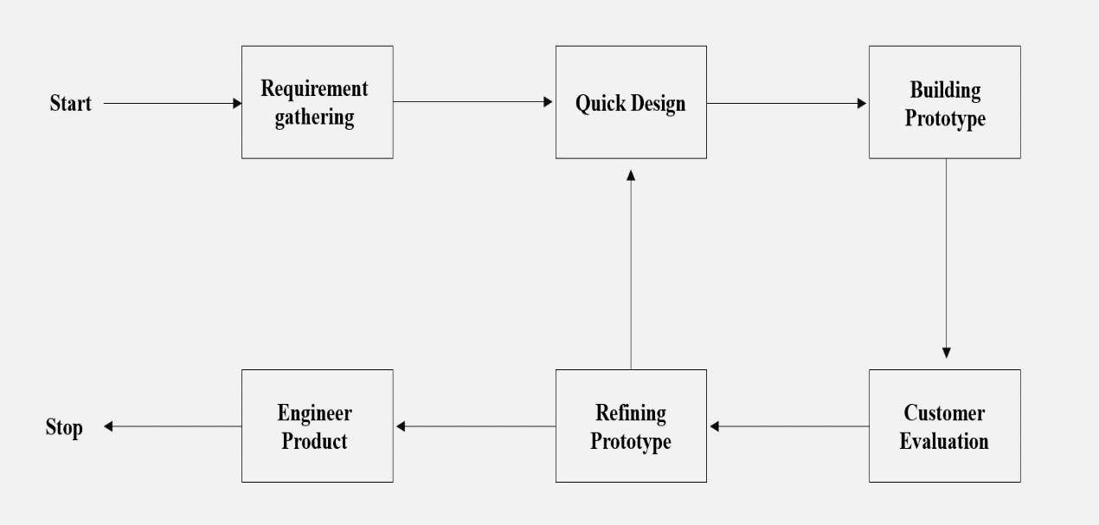

Figure 4 Protoype Model

The Prototype methodology is an iterative and incremental approach to software development that emphasizes the creation of early, simplified versions of a product to gather feedback and validate design decisions. This methodology is particularly useful in projects where user experience and design play a crucial role, such as developing user interfaces for applications or websites.

1. Requirement Gathering.
2. Design.
3. Prototype Development.
4. Feedback and Evaluation.
5. Iterative Refinement.
6. Incremental Development.
7. Testing and Validation.
8. Deployment and Feedback.

## 3.3.2.2 Project Planning Phase

The Project Planning Phase is a fundamental step in the project management process that plays a pivotal role in the successful execution of any project. During this phase, project managers and stakeholders establish a comprehensive plan that outlines the project's objectives, scope, timelines, resources, and strategies for achieving its goals.

## 3.3.2.3 Analysis of Project Requirement Phase

The Project Requirement Phase is a critical stage in the project management process where the project team works with stakeholders to gather, analyze, and document the specific needs and expectations for the project. It serves as the foundation for the project by ensuring that everyone involved has a clear understanding of what needs to be achieved and how to achieve it.

There are a number of different approaches to the project requirement phase. However, most approaches follow a similar process:

1. Initiation and Stakeholder Identification.
2. Requirement Elicitation.
3. Requirement Documentation.
4. Requirement Analysis.
5. Requirement Prioritization.
6. Requirement Validation.
7. Requirement Traceability.
8. Change Management.
9. Stakeholder Communication.
10. Requirement Sign-Off.

## 3.3.2.4 Prototype Design Phase

The prototype design phase of the application is the process of creating a visual and interactive representation of the application, before it is fully developed. This prototype is used to test the usability, functionality, and overall design of the application with users, and to get feedback to make necessary improvements.

## 3.3.2.5 Coding and Prototype Development Phase

During the coding and prototype development phase, the focus is on writing code and building functional prototypes based on the design specifications. This phase involves translating the design concepts into actual software components and developing prototypes that demonstrate the key features and interactions of the application.

## 3.3.2.6 Testing Phase

The Testing Phase, also known as the Quality Assurance (QA) phase, is a critical step in the software development process. It involves systematic and thorough evaluation of a software application to ensure it functions correctly, meets specified requirements, and delivers a positive user experience.

## 3.3.2.7 Updating and Maintenance Phase

The updating and maintenance phase is a stage in the software development life cycle that occurs after the initial release of the application. During this phase, the focus is on maintaining and improving the software by addressing issues, releasing updates, and providing ongoing support.

## 3.4 Justification of Choosing Evolutionary Prototype

The purpose evolutionary prototype is chosen based on the advantages below:

* This methodology allows a repeat of the improvement phases to pick outthe requirements which are no longer stated.
* This methodology is bendy as it can enhance the communication between developer and client. Changes that may be made from time to time are nolonger in trouble to fulfill the requirements of the client.
* The prototype's adjustments are to be more environmentally friendly and less difficult to manage.
* This methodology let developer put in greater effort and dedication to produce a wholly functional system.
* The nice of requirements and specifications can improve because the early determination of what the consumer needs can result in quicker and much less pricey software.

## 3.5 Analyze system requirements

System requirements analysis is a crucial phase in the software development process that focuses on understanding and defining the needs, constraints, and expectations of a software system. It involves a comprehensive investigation and documentation of what the system should accomplish how it should operate, and what constraints or limitations it must adhere to.

## 3.6 Summary

This chapter has mentioned a brief overview of the development methodologies as well as the purpose of using them. It also has pointed out some widely used software development methodologies with our proposed methodology and its justification. This chapter has discussed the phases (project planning, analysis, design & implementation of prototype, design prototype, coding & prototype development, testing, maintenance, and project planning) for the proposed project.

# Chapter 4

# SYSTEM ANALYSIS AND DESIGN

## 4.1 Introduction

System analysis and design (SAD) is a systematic approach to understanding, designing, and implementing efficient and effective information systems. It includes studying, analyzing, and documenting current business processes, identifying functional and non-functional requirements for the system, and designing solutions to address those requirements. The primary goal of system analysis and design is to create information systems that support and improve organizational processes, operations, and decision-making.

## 4.2 Result for Software Requirement

Therefore, here is an explanation for Functional, Non-Functional, and the Interface Requirements.

## 4.2.1 Functional Requirement

Functional requirement describes what the system should do or offers for users, and it specified by the users. It determined the system features; thus, it is easy to examine it.

Restaurant Supervisor Requirements:

* The restaurant supervisor must be able to see reservation details.
* The restaurant supervisor must be a member in Firebase.

Customer Requirements:

* Register: The customer should be allowed to register.
* Login: The customer should be allowed to login.
* Apply: The customer should be allowed to apply a booking request.
* Profile: The customer should be able to edit the profile.

## 4.2.2 Non-functional

* System availability: the system must be available for customer and supervisor without downtime as possible.
* Operating system: Android, IOS.
* Programming language & Framework: Dart, Flutter.

## 4.3 Use Case Diagram

In UML use case diagram is a way of showing the interactions between a system and its users.

In a use-case it describes the goals and scenarios that the users can achieve with the system. the restaurant supervisor can register in the application and manage restaurant information. Additionally, they can add and edit the restaurant menu. They can also view and modify reservation statuses and receive new reservations.

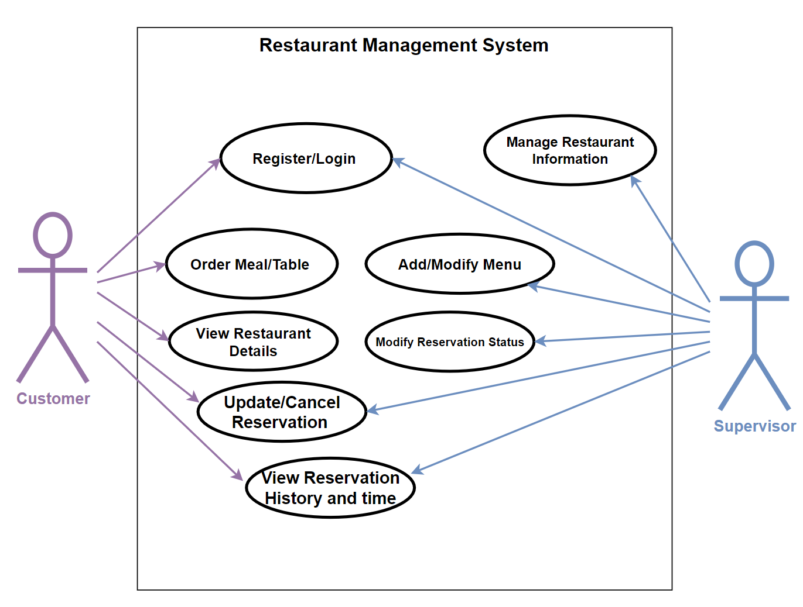

Figure 5 Use Case Diagram

## 4.4 Activity diagram

Activity diagrams are a form of Unified Modeling Language (UML) where graphical representations of the workflow are illustrated in a step-by-step process and activities are represented for the cycle, decision, and simultaneousness.

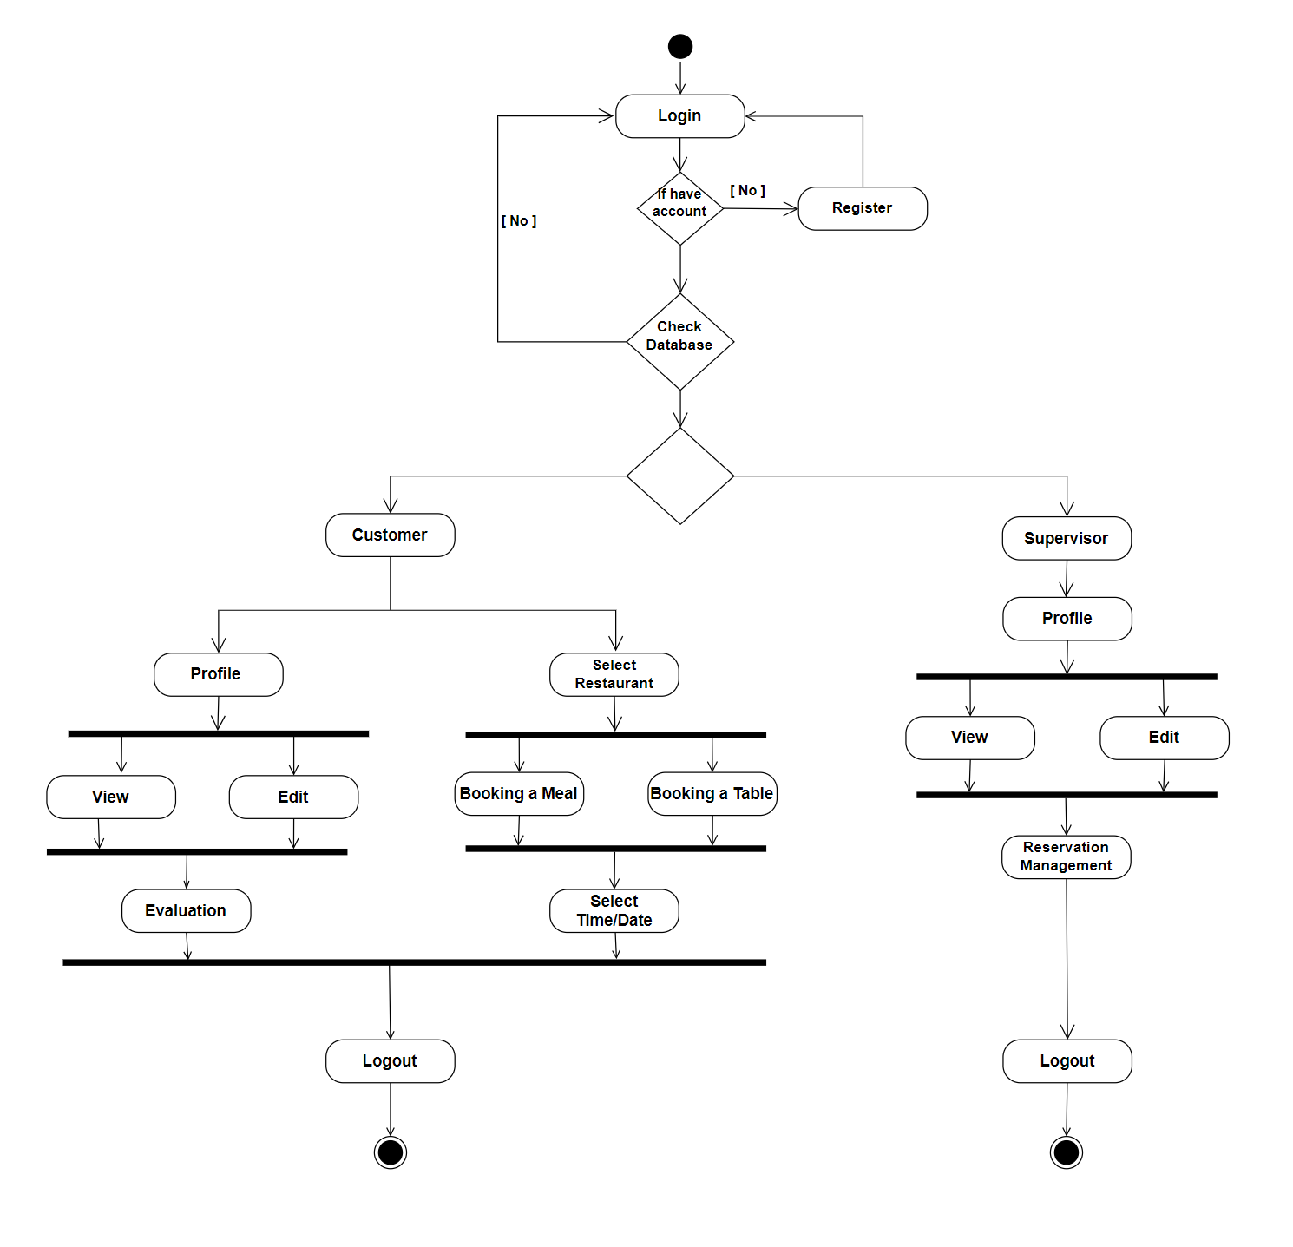

Figure 6 Activity Diagram

## 4.5 Sequence diagram

A Sequence Diagram for a booking application visually represents the chronological order of interactions and communications between different components or actors within the system. It illustrates how various entities collaborate to achieve a specific functionality, providing a step-by-step depiction of the flow of messages or actions. In the context of a booking application, such a diagram would showcase the sequence of events between users, the application, and any external systems. For instance, it could detail the process of a user making a reservation, involving actions such as selecting dates, checking availability, confirming the booking, and receiving a confirmation. Sequence Diagrams are valuable tools for understanding and communicating the dynamic aspects of system behavior, making them instrumental in the design and development of booking applications to ensure smooth and logical interactions.

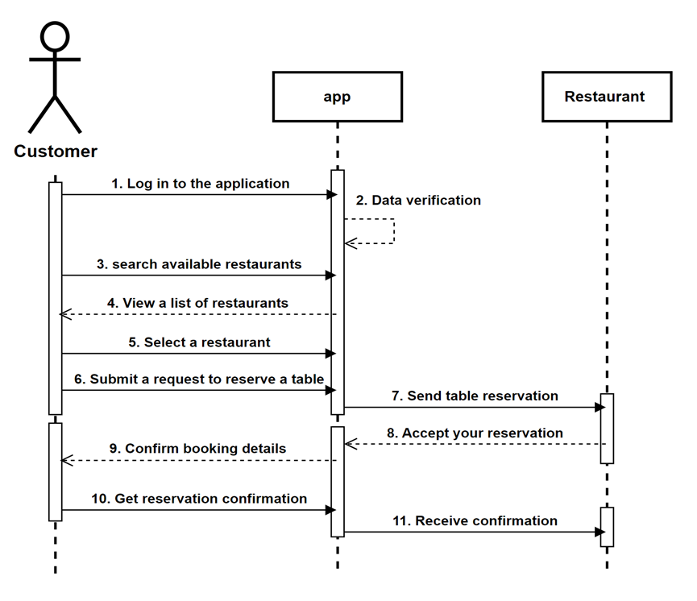

Figure 7 Sequence Diagram

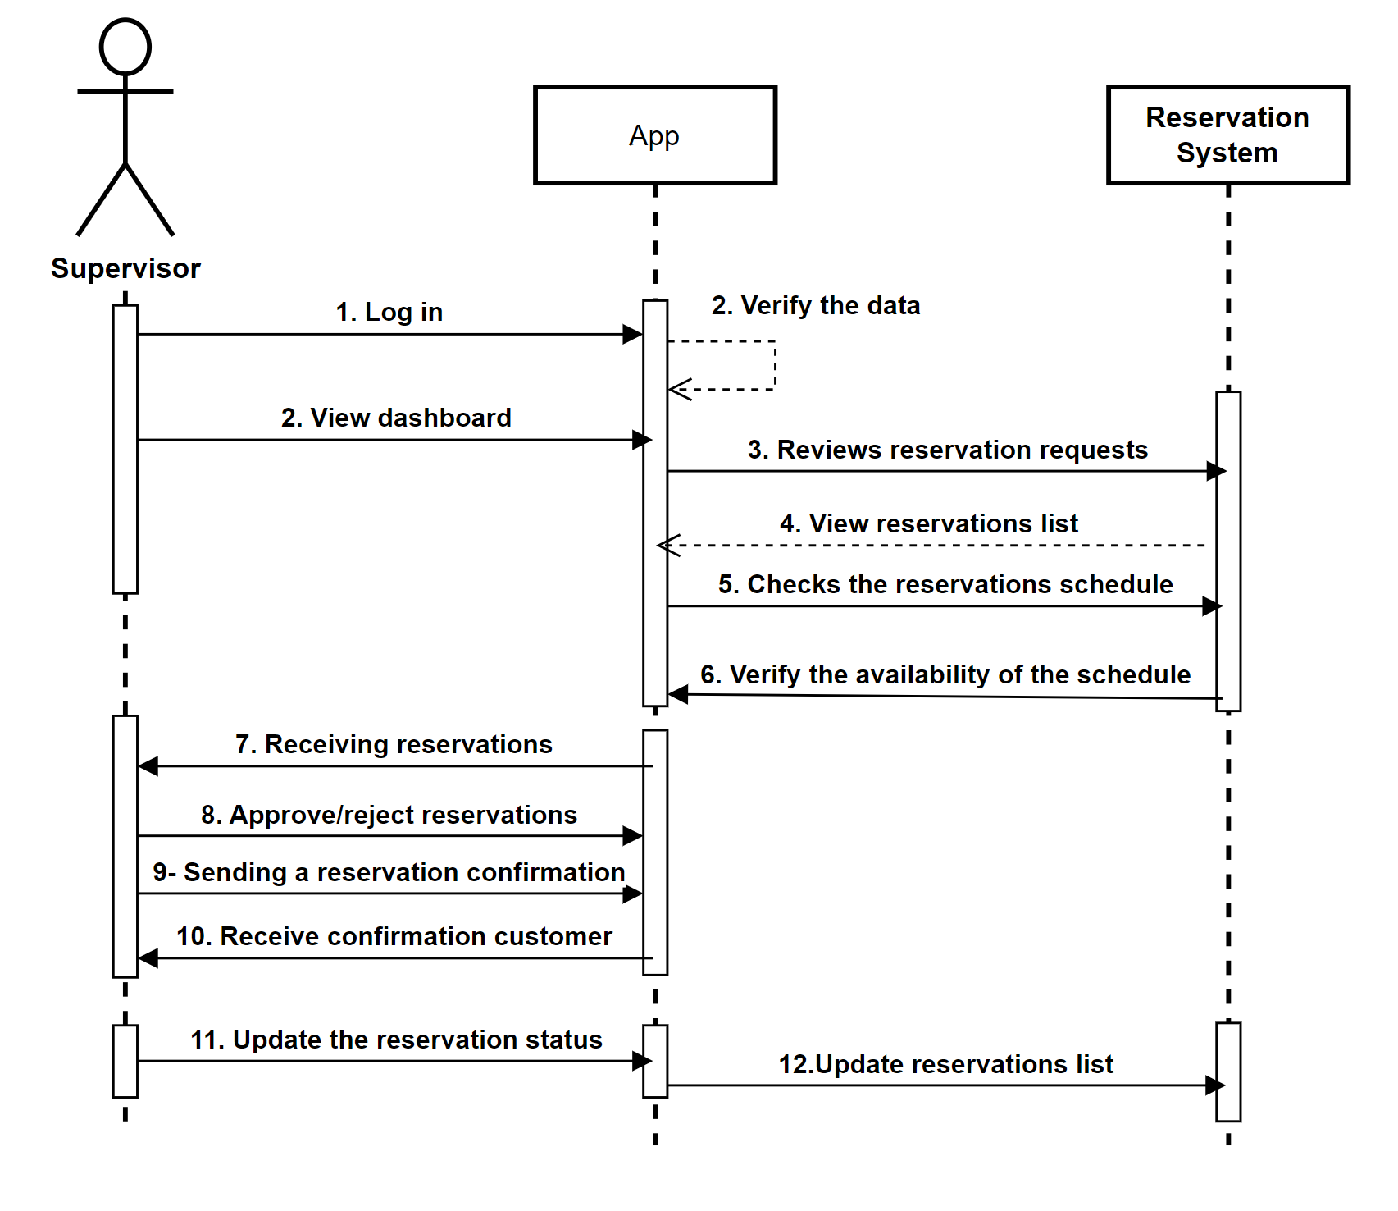

Figure 8 Sequence Diagram

## 4.6 Database Design

Database design, specifically Entity-Relationship Diagram (ERD), is a visual representation of the structure and relationships of entities within a database system. ERD diagrams use entities to represent real-world objects or concepts and relationships to define how these entities are associated with each other. Entities are depicted as rectangles, and relationships are depicted as lines connecting the entities. The ERD provides a clear and concise overview of the database's structure, including the attributes of each entity and the cardinality and type of relationships between entities. It serves as a blueprint for designing and implementing the database, ensuring data integrity, minimizing redundancy, and facilitating efficient data retrieval and manipulation.

Figure 9 Database design (ERD)

## 4.7 Conclusion

In this chapter the analysis and design processes for the application table booking in restaurant. These phases provide information for the upcoming system development phases. Which will occur in senior project II.

**Chapter 5**

**RESULT, ANALYSIS AND DISCUSSION**

## 5.1 Introduction

This chapter describe the user interfaces of Dart and Firebase, Discussion and analysis of the result, we will start with the login & register screen which is the main screen for the application, Flutter framework helps us decorate and design the application, Firebase helps us in the backend analysis and to deal with data.

**5.2 Main Screen**

This is the first screen of our app, it appears once you run the app, it’s Login and Register page that required to press Register or Login in order to use the app.

**5.3 Register & Login**

This page where the user should create an account if the user using the app for the first time, it required to enter Full Name, Email Address and Password.

# 5.4 Home Screen

This is the home screen where displaying a collection of restaurants to choose and book.

**5.5 Restaurant’s profile screen**

This is the restaurant’s profile screen where the user can enter number of people, time, date and the branch of the restaurant.

**5.6 Restaurant’s Menu**

Here is where the user can select items and pay for it in order to book a table and prepare the order.

**5.7 Billing Screen**

Here’s where the user pay for the items that has been selected from the menu, after the user pay it will display payment successful, and the reservation details will sent to the restaurant.

**5.8 History Screen**

History page will display last reservation details.

**5.9 User Profile & Profile Update**

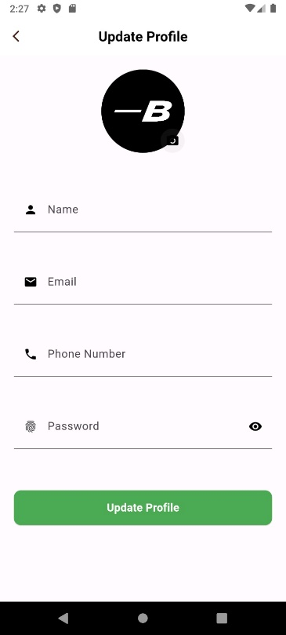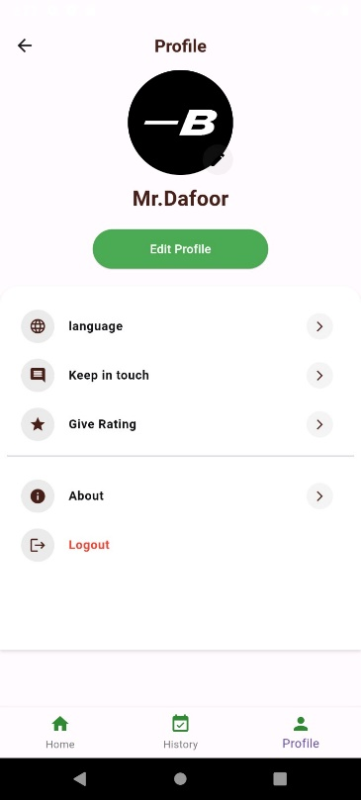

This is where the user can enter and update personal information and log out, also user can change language.

**5.10 Security in our system**

We only can see the Email, Provider, Date of Create and Signed, User ID and no one be able to see the sensitive data that related to the user, for example: Password, Location.

**5.11 Connected with Firebase**

**5.12 Conclusion**

This chapter discussed the User interfaces of the application and the firebase connection, with displaying the authentication security of our application, by encrypting the sensitive data like, Password and Location.

**Chapter 6**

**CONCLUSION**

**6.1 Introduction**

In this phase, we have developed (MAEDA) App for restaurant table reservation, it’s an intermediary for restaurants to make a reservation through it, with the possibility to see the restaurant’s menu and make pre-order, different types of restaurant all in one app to facilitate the customer’s search and selection. On the other hand, restaurants will be able to manage reservations and prepare the table in shortest time possible because of pre-booked, long-term effect is to enhance the customer’s experience.

**6.2 Achievement of Project Objectives**

The main goal of our project is to share the knowledge of the reservations idea to enhance the interests in the restaurant’s industry, that will affect positively in the short-time and long-time performance, decreasing the waiting list and reduce the waiting time are one of the main reasons to reserve a table.

**6.3 Suggestions for Improvement and Future Works**

We see that adding a graph line to express the popularity and the degree of crowding, will explain to many people about the performance of the restaurants, also by the time many restaurants take a place in the app; adding a search bar to search about a specific main course and see the restaurants that have.

# References

[1] Kimes, S. E. (2011). Customer attitudes towards restaurant reservations policies. Journal of Revenue and Pricing Management, 10, 244-260.

[2] Dixon, M., Kimes, S. E., & Verma, R. (2009). Customer preferences for restaurant technology innovations.

[3] Barbara Bray (Technology and its Impact on Society and Culture, Sept 25,2007)

[4] Hemmendinger, D. (2018, November 21). Web script. Encyclopedia Britannica. <https://www.britannica.com/topic/Web-script>

[5] https://sceel.io/wp-content/uploads/2019/10/blog-flutter-header.jpeg

[6] <https://aws.amazon.com/what-is/flutter/> © 2023, Amazon Web Services, Inc. or its affiliates. All rights reserved

[7] Kulinski, Swav (2018-12-07). "Flutter — The sky's the limit". Kin + Carta Created. Retrieved 2023-06-20.

[8] "A Bit About Dart - Learn Dart: First Step to Flutter". Educative: Interactive Courses for Software Developers. Retrieved 2023-06-20.

[9] https://swansoftwaresolutions.com/a-programming-language-called-dart-what-is-it-and-how-is-it-used/ Copyright © 2020 Swan Software Solutions. All Rights Reserved

[10] https://mytable.sa/#/ © 2023 MyTable Technologies Inc

[11] Requeue. (2023). Retrieved 10 October 2023, from https://requeue.net/

[12]Kofler, M. (2005). What Is Firebase?. *The Definitive Guide to Firebase*, 3-16.‏